**Project Name: The Online Book Store**

**Date: 07/10/2021.**

**Copyright Notice**

This document contains proprietary information of HCL Technologies Ltd. No part of this document may be reproduced, stored, copied, or transmitted in any form or by means of electronic, mechanical, photocopying or otherwise, without the express consent of HCL Technologies. This document is intended for internal circulation only and not meant for external distribution.

**Revision History**

| **Version No** | **Date** | **Prepared by / Modified by** | **Significant Changes** |
| --- | --- | --- | --- |
| 1.0 | 07/10/2021 | Vuong Thi Dieu Linh | Linh |
|  |  |  |  |

**Table Of Contents**

1.1 Project Overview 3

1.2 Scope 3

1.3 Out of Scope 3

1.4 Intended Audience 3

1.5 High Level Use Cases 4

1.6 Use Cases detailed 4

1.7 User Interface Modules 5

1.8 Technical Architecture 8

1.9 Technical Detailed Description 9

1.10 Sequence Diagram 9

1.11 Database Entity Relationship Diagram 13

1.12 Non Functional Requirements 13

## **Project Overview**

At present, more and more bookstores are opened and buying or viewing the available books at offline bookstores is currently done manually where the customers have to go to the bookstore to check the available books. This may become a waste of time if the customer’s desired book is unavailable at the bookstore and it is inconvenient for the customers from remote areas to buy books. Moreover, it is difficult for the employees of this bookstore to manage books and guests in the bookstore.

Therefore we decided to establish an Online Bookstore system. This is an online management software monitoring and controlling the transaction in a bookstore. This project mainly focuses on basic operations in a bookstore like selling books, adding new books, updating new information, searching books, viewing books, adding admin, edit admin, delete admin…and facilities that allow users to buy books. Besides, the purpose of this document is to analyze and elaborate on the high-level needs and features of the Online Bookstore System.

## **Scope**

The Online Bookstore System is basically updating the manual bookstore system into a internet-based application so that the users can know the details of their accounts, availability of books and buying books online

The project is specifically designed for the use of admins and users. The product will work as a complete user interface for bookstore management process, user's information and sell books for ordinary users.

## **Out of Scope**

- Not other than mentioned above in section 1.2

## **Intended Audience**

The Online Bookstore System that is to be developed provides the users and admin of the bookstore with books’ information, online shopping of books and many other facilities.

| **Name** | **Description** | **Responsibilities** |
| --- | --- | --- |
| Admin  Customer | Bookstore employee  manages books  The person who want to buy  books from the bookstore | Uses the bookstore management  system to manage books, category  and users in the store  Uses the bookstore management system to buy books and update their account |

## 

## **High Level Use Cases**

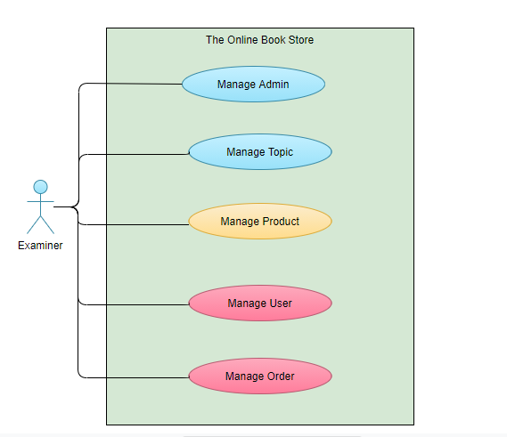

## **Use Cases detailed**

* Blue use case: Completed
* Yellow use case: Processing
* Red use case: Will develop in the future

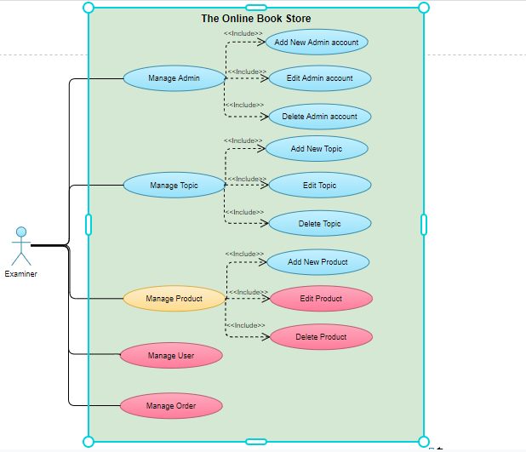

## **User Interface Modules**

* User interface must be:
* Must be secure, convenient and extensible
* Protect authorization information from unauthorized access, the maintenance of customer confidentiality and tracking of payments in progress
* Be efficient in terms of both speed and user interaction
* Be easy for users to use.

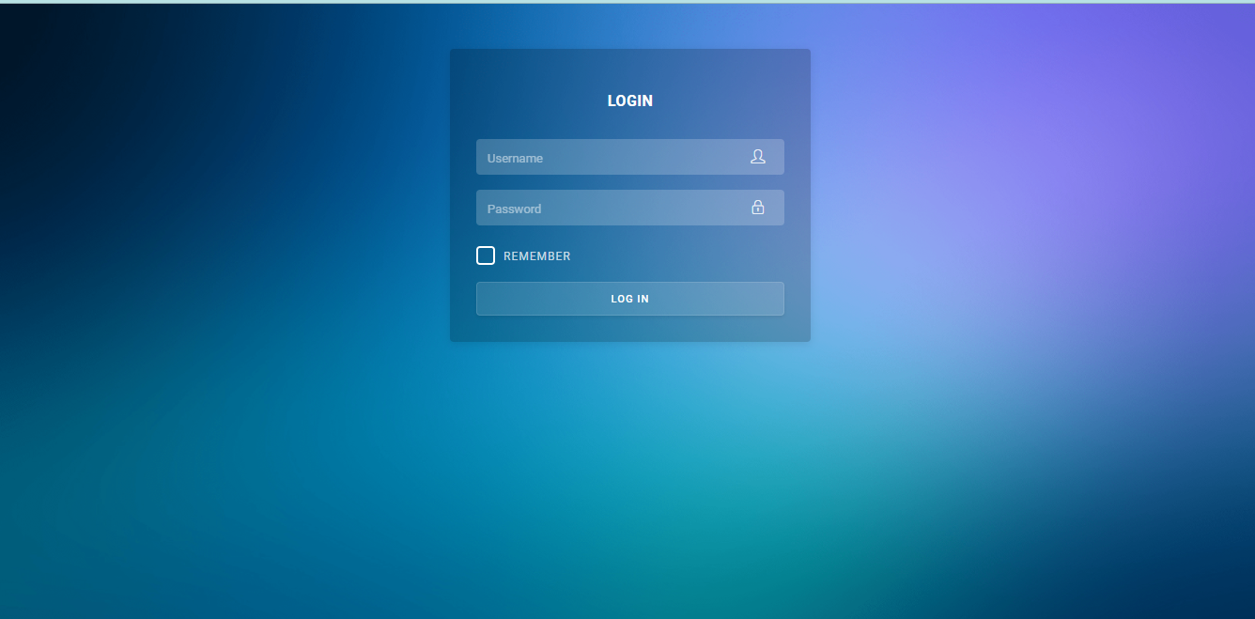

1.7.1. Login Interface

- This web page is used for a admin to login and enter the website

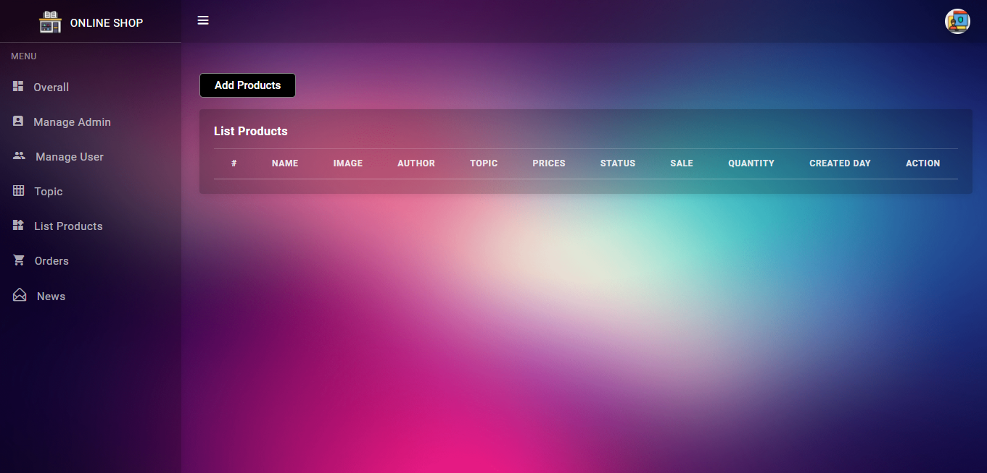

1.7.2. Add Product Interface

- This web page is used for a admin to add new books

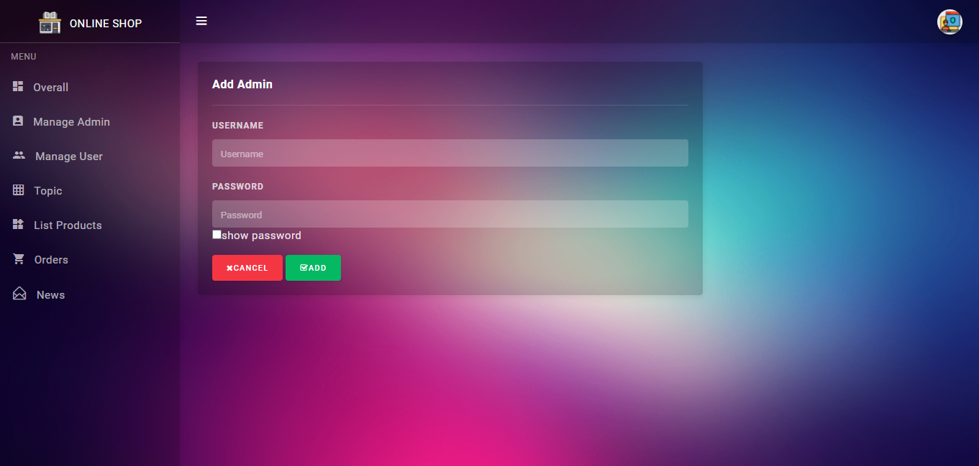

1.7.3. Add New Admin Interface

- This web page is used for a admin to add another admin

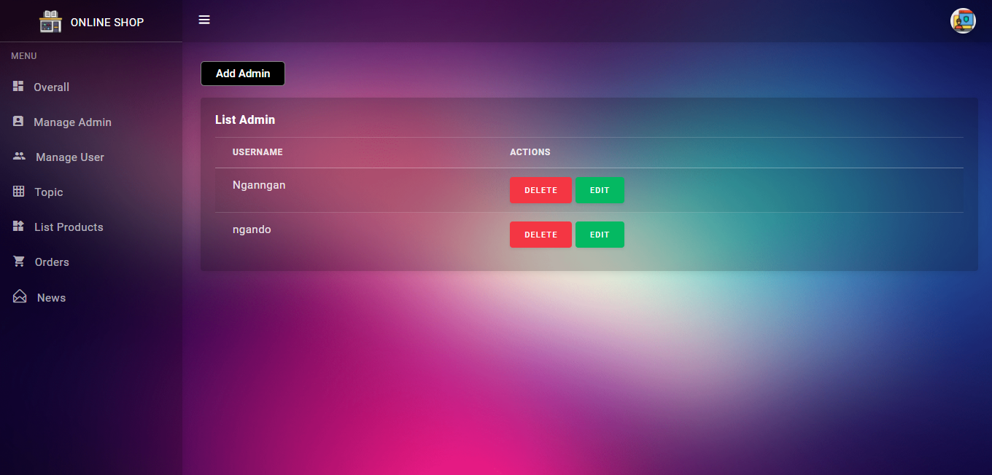

1.7.4 Delete Admin Interface

- This web page is used for a admin to delete another admin

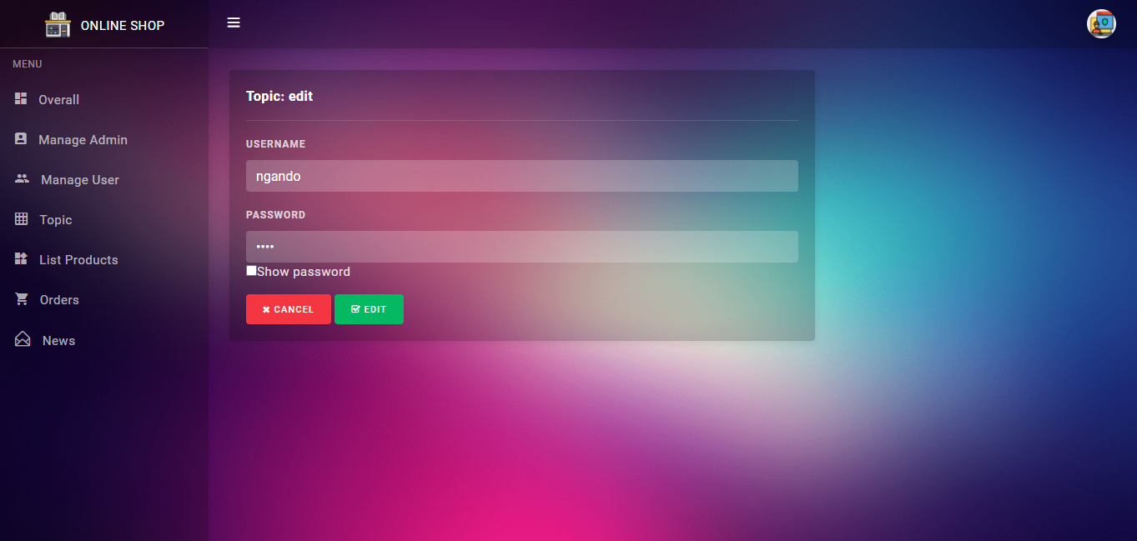

1.7.5 Edit Admin Interface

- This web page is used for a admin to edit their profile

## **Technical Architecture**

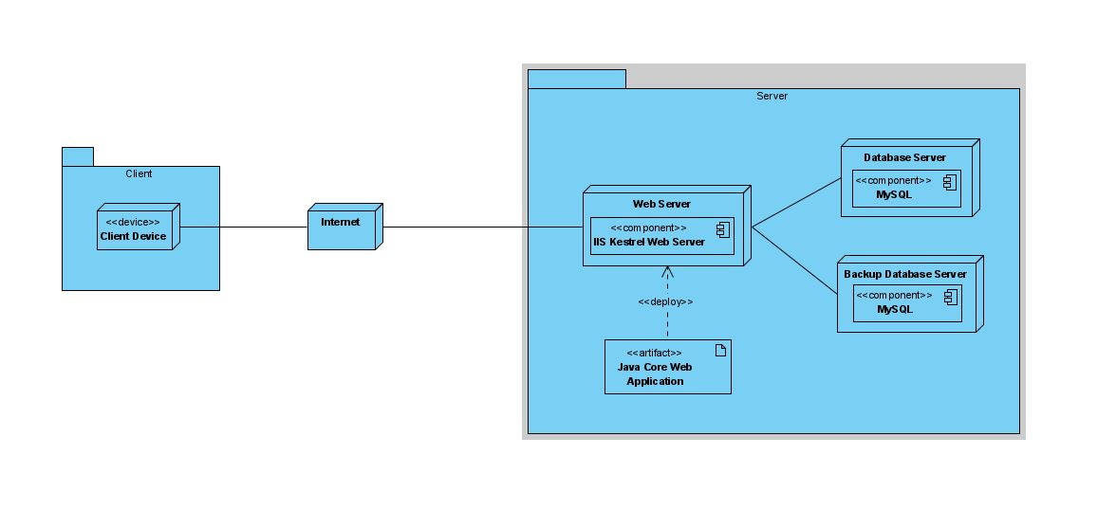

## **Technical Detailed Description**

| **Client Application** | **Web Server** | **Database Server** |
| --- | --- | --- |
| - Display books  - Communicates business rule to users  - Provide all user interaction  - Communicates with WebServer to process information | - Receives requests from client  - Communicates with database server  - Responds to client requests  - Applies business logic | - Manage data interaction  - Contain all data in application  - Connect with SQL server  - Connect with WebServer |

## **Sequence Diagram**

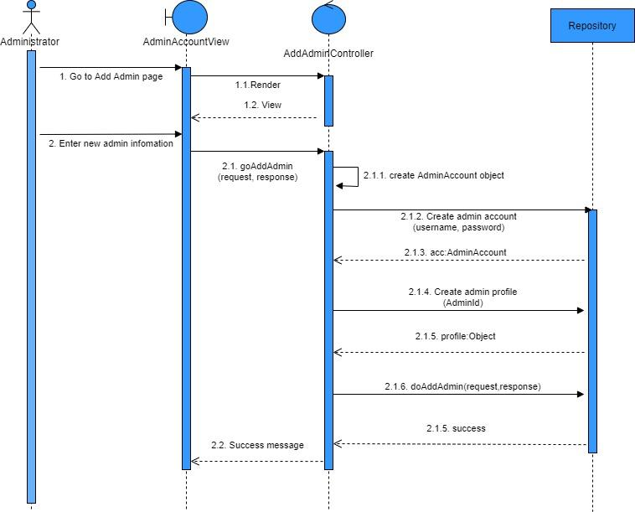

Add new Admin

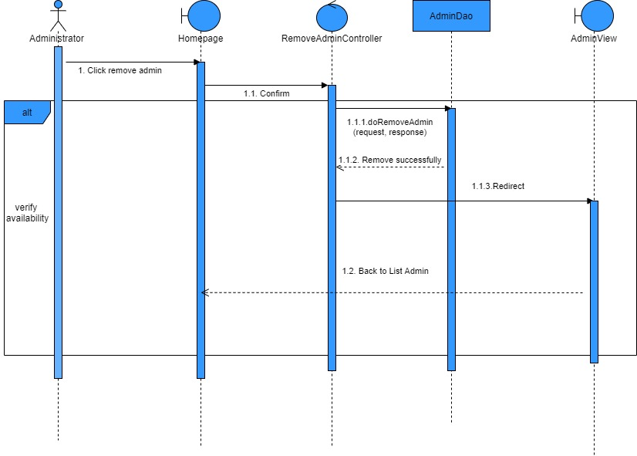

Delete Admin

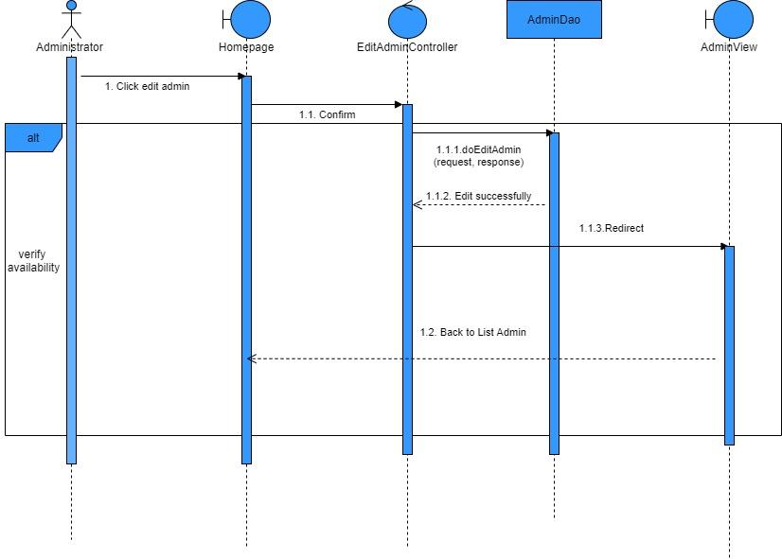

Edit Admin

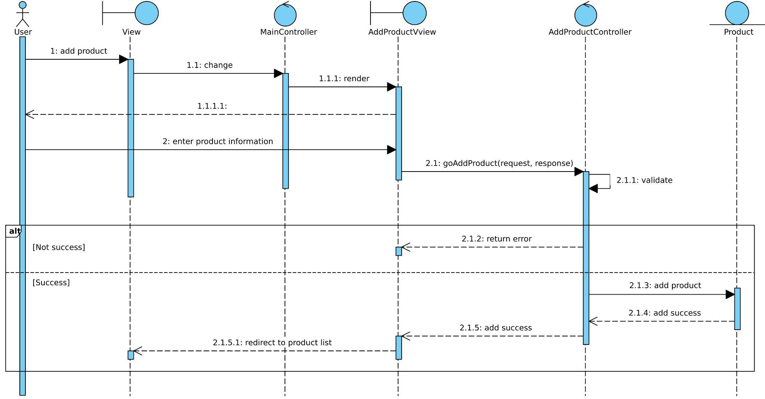

Add new Product

## 

## **Database Entity Relationship Diagram**

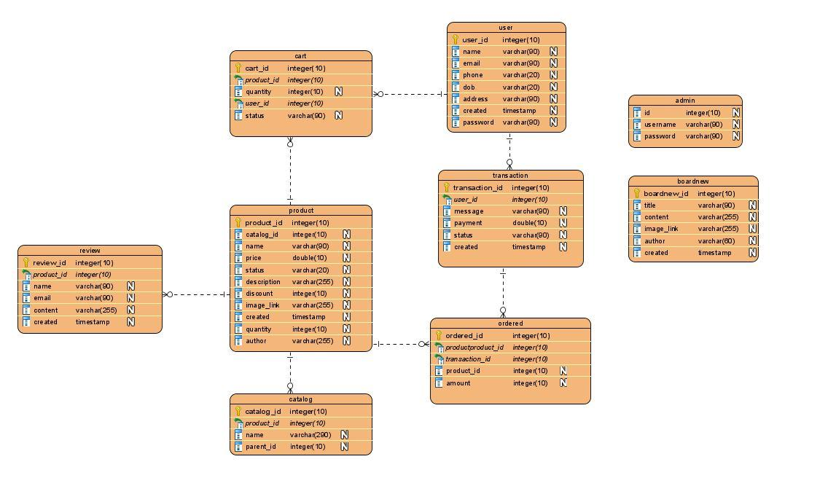

## **Non Functional Requirements**

None